CryptoniX

Team Members -:

Anshika Kamboj - 21103148

Nipun Mittal - 21103162

Vaibhav Singh - 21103151

Neelansh Sharma - 21103175

Project Objective -:

Our Project aims at making a software/interface which shall aid in solving and going through various puzzles, clues, questions, etc. in a Cryptic Hunt which in turn leads to security in different and various aspects.

Modules -:

1. string
2. linked lists
3. hashing
4. iterator
5. algorithm
6. exception
7. iostream
8. fstream.h
9. stdlib.h
10. conio.h
11. cstring
12. list
13. vector
14. map
15. time.h
16. Windows.h
17. math.h
18. sstream
19. cctype

List of C++ features used -:

1. Object Oriented Concepts like Classes
2. Exception Handling
3. File Handling
4. Standard Template Library (STL)

List of DSA concepts used -:

1. Arrays
2. Linked Lists
3. Vectors
4. Maps
5. Searching
6. Recursion
7. Hashing
8. Collision Handling
9. Multilist

Design of the project -:

The project consists of 5 project file, namely:

1. cryptonix.cpp (author Nipun Mittal 21103162
2. steg.cpp (author Nipun Mittal 21103162)
3. clue.cpp (author Anshika Kamboj 21103148)
4. ciphers.cpp (author Vaibhav Singh 21103151)
5. strength.cpp (author Neelansh Sharma 21103175)

using g++ cryptonix.cpp will be saved as an executable file namely cryptonix.exe

(command to be used ‘g++ cryptonix.cpp -o cryptonix.exe’ by having installed gcc and g++ in command in windows or pre-installed/installed version in linux based systems and using gcc/g++ in command prompt or terminal by opening them in the folder containing all the files)

NOTE: All the 5 files and any .txt file required for steganography must be in the same folder!!

**Main Screen:**

Here the user first arrives and gets the options to choose what feature he/she wishes to use or are in need of. After selecting the option the menu for the respective option will be visible wherein required inputs can be given for desirable outputs.

**Options:**

User is to choose from the variety of options provided on the main screen which include,

Cryptic Clue Solver which can be used to get possible answers to cryptic clues or questions which have twisted language or feel broken maybe.

Text Steganography where in text can be hidden in other text to convey a message secretly or hiding words or phrases in plain sight which might be readable by some and not readable by others.

Cryptography in which we have provided a few ciphers to use and encrypt messages. Here, the text itself is encrypted and possibly the user has to give specific to access the content of ciphered text.

Password Strength Checker which allows user to check the strength of a word for security reasons or to lead to a clue based on a predetermined conditions.

**Difference between Steganography and Cryptography:**

**Steganography** is a method in which secret message is hidden in a cover media. Steganography means covered writing. Steganography is the idea to prevent secret information by creating the suspicion. In steganography, structure of data is not usually altered.

**Cryptography** means secret writing. In cryptography, sender does not send message directly to the receiver, before sending information to the receiver information or plain text is converted into cipher text by using some encryption algorithm then send to the receiver and receiver decrypt the cipher text into plain text to read the original information.

**Output Screenshots:**

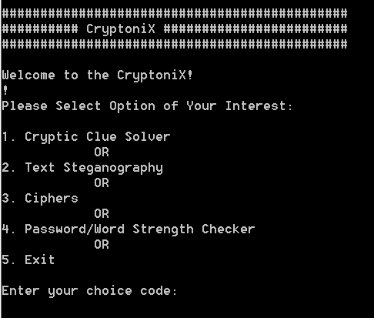

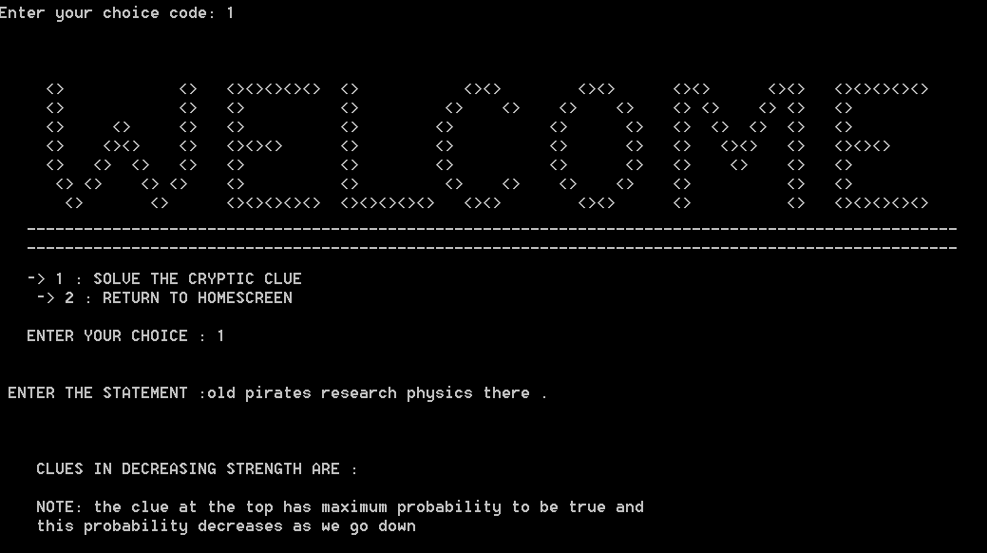

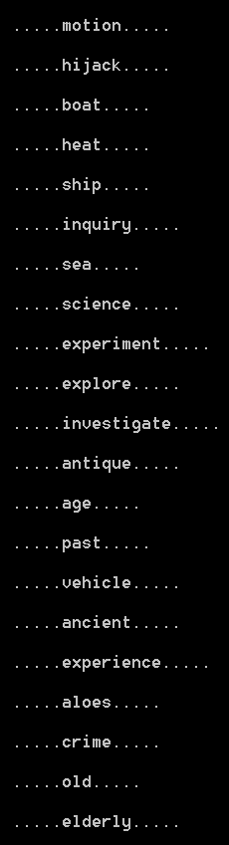 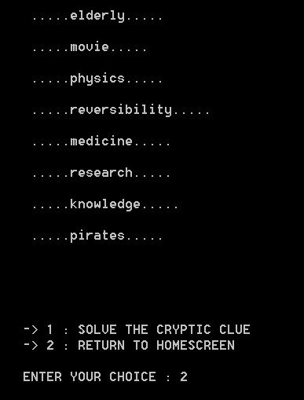

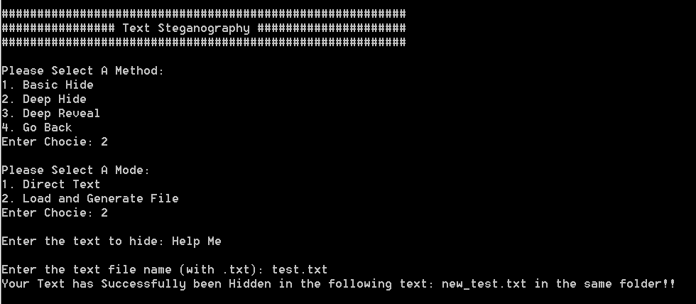

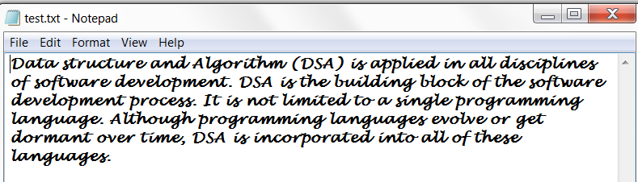

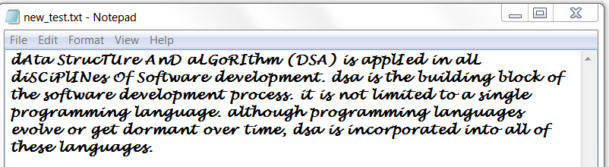

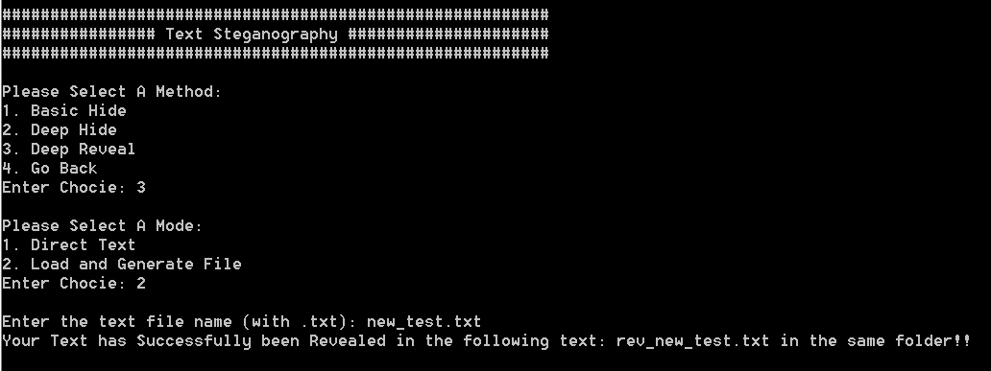 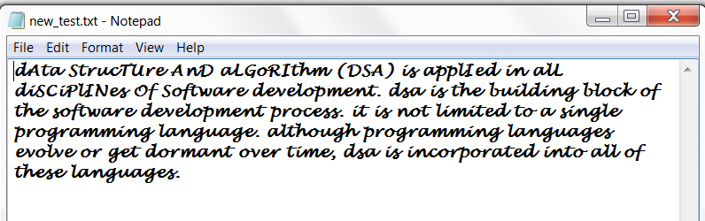 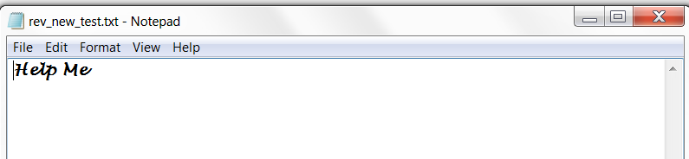

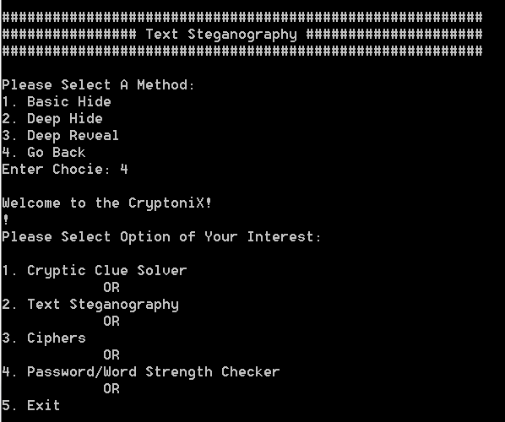

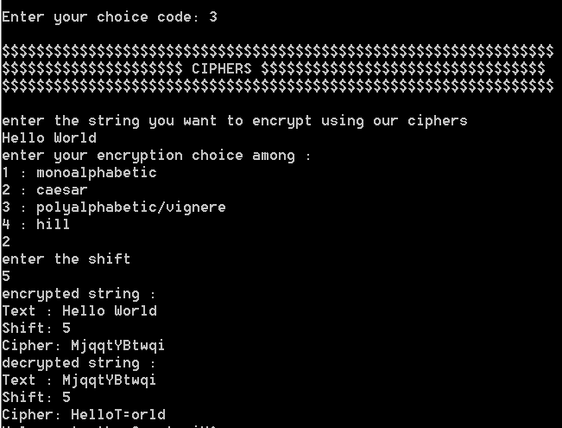

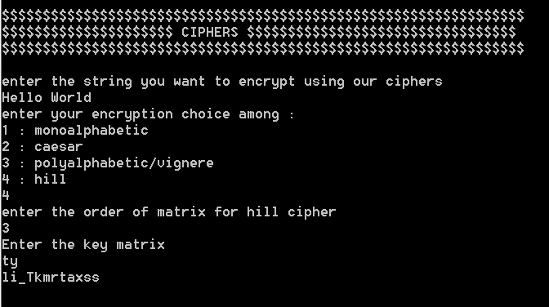

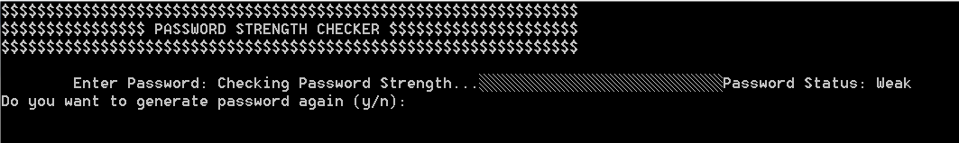 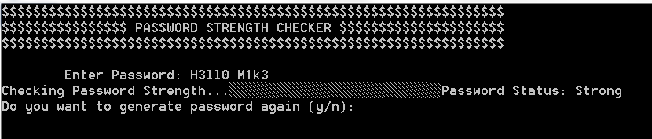 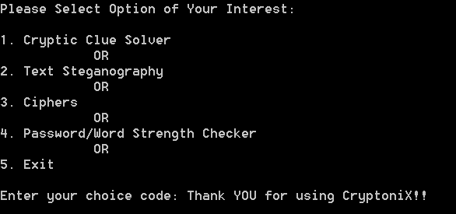



Files after execution of the code :

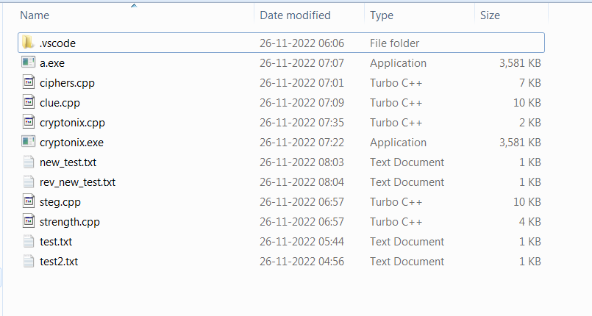

**References:-**

1. GeeksforGeeks
2. Stackoverflow
3. TutorialsPoint
4. Programiz
5. Pointers in C/C++
6. Quora
7. Class Slides